**Question 1:** A square prism, side of base 40 mm and axis 60 mm long, rests with its base on HP such that one of its rectangular faces is inclined at 30° to VP. A section plane perpendicular to HP and inclined at 60° to VP passes through the prism such that a rectangular face which is making 60° with VP is cut into two halves. Draw the top view, sectional front view and true shape of section.

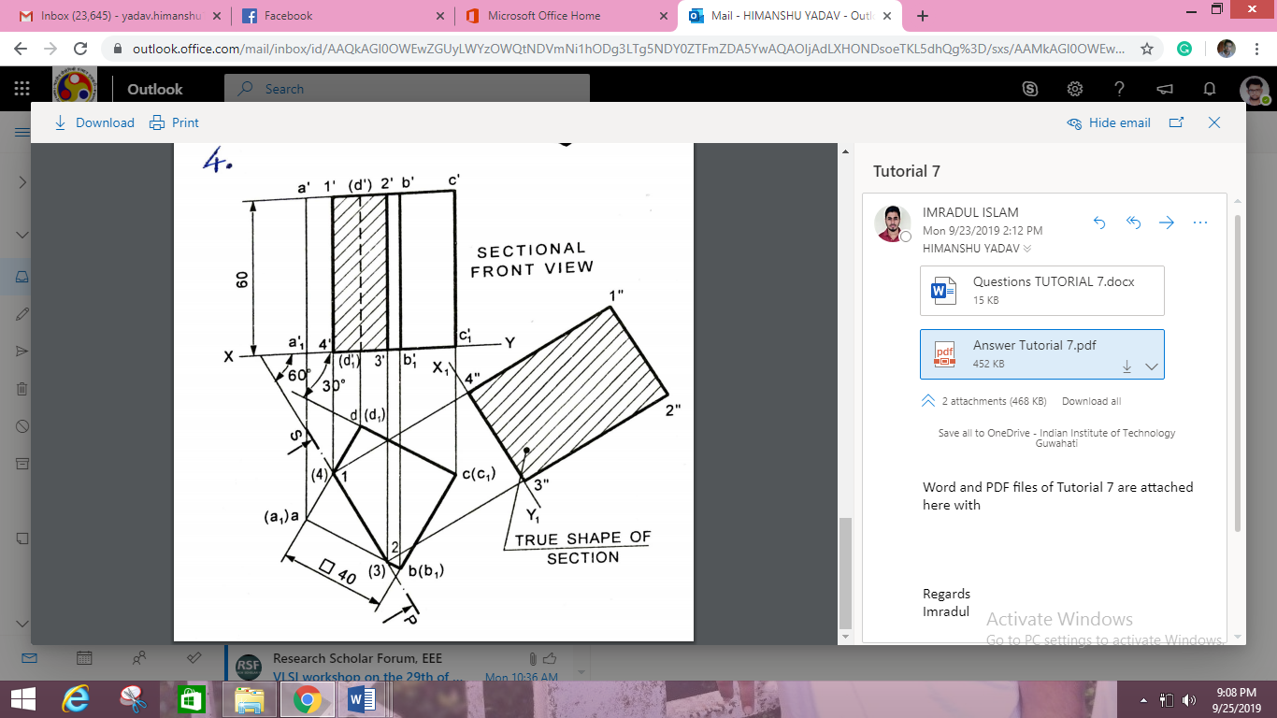

**Question 2:** A cube of 50 mm side rests with one of its edges on HP such that both of the square faces containing that edge are making equal inclination with HP. A horizontal section plane cuts at a distance of 18 mm below the top edge. Obtain front and sectional top views.

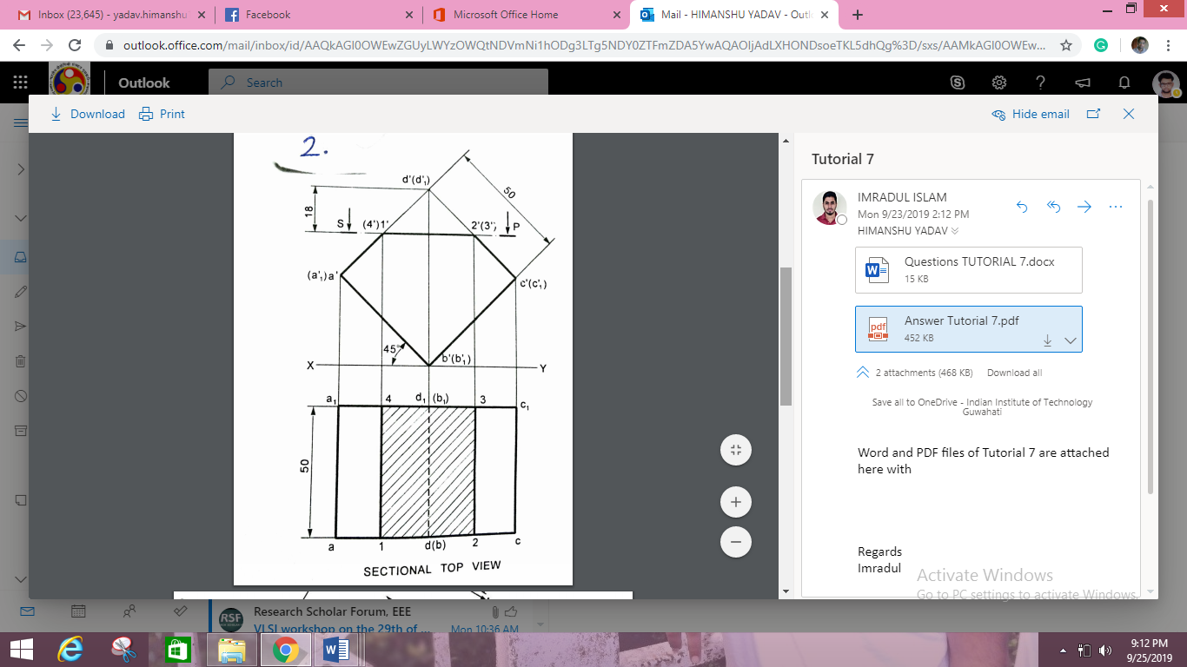

**Question 3:** A Square prism, side of base 40 mm and axis 65 mm long, rests with its base on HP and one of its rectangular faces is inclined at 350 to VP. A section Plane perpendicular to VP and inclined at 550 to HP cuts the axis of the prism at a point 15 mm from its top end. Draw the sectional top view and true shape of the section.

